2022
I-44 Winter RC Shootout
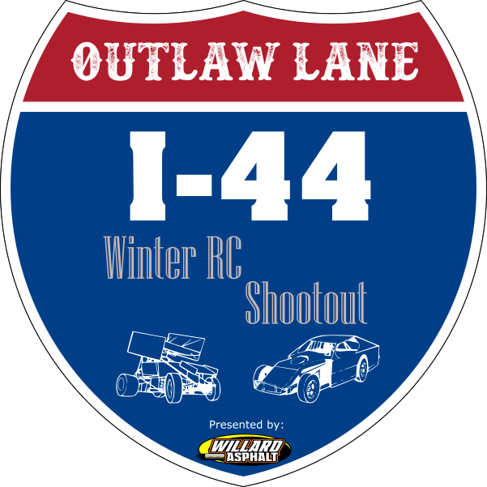

Racing Etiquette
Drivers are expected to follow some simple guidelines for racing etiquette.
- No abusive language toward Marshalls or other drivers will be tolerated.
- No corner-cutting or short-cutting the track. If you accidentally short-cut, wait either for a marshal to return you to the correct part of the track, or wait long enough to ensure that no advantage is gained. This applies even if you accidentally short-cut due to a crash that is not your fault.
- No ‘hacking’ other drivers. Intentionally or recklessly crashing into other cars is called hacking. It’s your responsibility to ensure you leave the drivers around you enough space – including not charging into corners and using other cars as brakes!
- When being lapped by faster drivers, it’s polite to leave a little space to ensure they can get by within minimal delay. You don’t need to pull off the track or stop – just leave a little room and talk on the driver’s stand. For example, you might say “Go inside on the next corner John” and just leave enough room for the driver lapping you to do so.
- If you feel aggrieved about an incident on the track, please take it up with the race director.
Marshalling
Marshalling is part of racing. The task of a Marshall is to upright overturned cars, return crashed vehicles to the racetrack, and separate vehicles that have become locked together. Guidelines for Marshall (all of us) are:
- You are obligated to Marshall the race that you aren’t racing in (rule of thumb is the very next race after you race). If you fail to Marshall, your race result may be cancelled. Repeated failure may result in exclusion from the event.
- Your first responsibility as Marshall is your own safety. Don’t enter the track unless you are certain there are no oncoming vehicles that threaten your safety.
This is particularly true if you are marshalling on the straightaways.
- Please don’t eat, drink or film with a cell phone while marshalling.
- If multiple vehicles crash, generally try to fix them in the order they crash.
- Place vehicles back on track facing the correct direction.
- If a driver has the throttle opened, don’t pick up the vehicle. Standing over it, hands in the air, indicates you are waiting for the driver to release the throttle.
- Marshalls are not in place to repair broken vehicles. If a vehicle breaks, remove it from the track and pass it around the outside (through other Marshalls) back to the pit area for repairs.

Seeding round rules:

- Seeding rounds will be 2 minutes in length
- Seeding is the individuals fastest 3 consecutive laps
- Seeding results will determine round 1 heat placement

Heat race rules:
- Each heat race will be a 35 lap event.
- Each heat race line up grid max is 6 vehicles. Heat race grids will be divided into equal group heat events.
- Heat races are used to qualify for the mains. This is to determine who qualifies for the “A” main and lower mains.
- Each heat group may compete or there may be a resort for both races utilizing the standard rule package for heat races.

Main rules
- “A” Mains will be 45 lap events. Lower mains through the B main will be 35 lap events.
- Lineups will be based on qualification points from heat races as determined by the computer system, seeding round results will be used as tie-breakers.
- There is only one “A” main event per (class) race event.

Vehicle transponder

Each vehicle is required to have their own transponder that will work with the MYLAP timing system. These transponders can be found at: https://www.mylaps.com/en.

Compatible MYLAP transponders that will work with our RC4 MYLAP system:

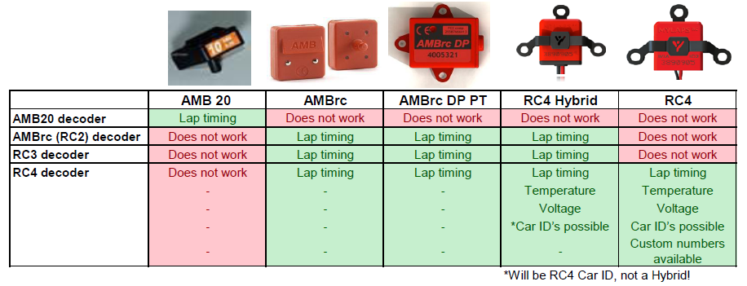

If a transponder fails to work during a heat race that vehicle is awarded last place. If the transponder isn’t fixed; the driver can continue to race but will not be scored.

If a transponder fails to work after the first heat race all rules in the above paragraph apply.

It is the responsibility of the driver to ensure his/her transponder always works properly.

CLASSES
SC MODIFIED:
Must be a SC Based Chassis
Carbon fiber chassis are allowed. Must meet the following specs.
All suspension components, transmission, front and rear bulkheads must be on center line of the vehicle.
All larger volume OEM Chassis are legal IE “AE, TLR, Traxxas”
Aftermarket or specifically built chassis and kits must conform to the following specifications.
Maximum Chassis width 7”
Minimum Chassis width 5 1/8”
Maximum left side of chassis can be from centerline is 3 1/2”
Right side must be a minimum of 2.25” from centerline to outside edge of chassis.
Cages: Must represent a cage, no solid plastic cages, must be cut the same on both sides.
Minimum wheelbase 12.5”
Maximum wheelbase 13.5”
Shock bodies min length 1”
Front Track width Min 11.42” *UPDATED TO MEET ROAR SPECS*
Front track width Max 11.65” *UPDATED TO MEET ROAR SPECS*
Front Suspension arms must be equal size left and right
Rear Suspension arms must be equal size left and right
Adjustable Rear Suspension arms are allowed.
Battery must be mounted on the centerline of the vehicle. Can be either designed front to back or sideways across the chassis but center of battery must be on centerline of chassis.
MOTOR and ESC: Open
- No 8th scale motors allowed
BATTERY: 2 Cell Hard Case LiPo battery only; 8.40 VOLTS MAX.
TIRES: Open
- Only Short Course Wheels

SC BODY RULES:
Body Length, Width, and Height:
13" max body width
28" max length (bumper to spoiler)
7.5" max body height measured from bottom of chassis

Center deck:
1" max deck rake.
1" max center deck taper (widest point of the deck can only be 1" wider than the narrowest point of deck)

Spoiler:
1.5" max spoiler height
Spoiler end plate max 2” high off-center deck and 3.25” long

Roof:
0.5" max roof rake measured from deck
Maximum Roof width 9"
Maximum Roof length 9"
No roof spoilers, a bend down at the trailing edge of the roof is allowed for strength
Roof side rails allowed but must have a scale appearance and be on both the left and right sides of the roof.
1/4" bend down at the leading edge of the roof allowed.
Roll cage/Roof Supports:
Roll cage/roof supports must be cut or formed to resemble a roll cage. No solid panel roof supports. Window netting and rock guards are allowed.

Nose:
Nose sides can extend a max of 1/4” above the plane of the nose panel
Nose sides can extend a max of 1/4” above the plane of the hood panel
Nose cannot extend past the inner edges of the front wheels
Main nose panel must be a flat plane. No concave or scooped noses allowed.
Rear wheel wells must be cut out to expose most of the rear wheel
Left and right windows and sails can be open as long as both sides are the same

410 SPRINT
DODC RULES APPLY
BATTERY: 2 Cell Hard Case LiPo battery only; 8.40 VOLTS MAX.
MOTOR and ESC: Open

TIRES: Open

OPEN LATE MODEL:
DODC RULES APPLY
BATTERY: 2 Cell HARD CASE LiPo battery only; 8.40 VOLTS MAX.
MOTOR: Open
ESC: Open
TIRES: Open

MIDWEST MODIFIED:
MOTOR and ESC: Open
BATTERY: 2 Cell HARD CASE LiPo battery only; 8.40 VOLTS MAX.
TIRES: Open
BODY RULES: See DirtOval.com 1/10 Mid-West Modified Rules

Street Stock:

Any 1/10th scale buggy. Must be a factory based off-road buggy.

Approved manufacturers are Associated, Losi, Traxxas, Kyosho, Durango, Team C, Xray, Yokomo, Hobao H2.

Chassis must remain stock, no aftermarket/non-OEM upgrades except RPM Brand parts designed for the chassis. OEM Optional parts sold by these companies; designed for their cars are allowed.

Big Bore and threaded OEM Shocks are allowed.

SPRINGS: They can be from any manufacturer in the RC Industry not only OEM.

Rear wheel drive only.

Mid or rear motor allowed.

Adjustable rear A arms are NOT allowed.

BATTERY: 2 Cell HARD CASE LiPo battery only; 8.40 VOLTS MAX.

MOTOR: Open

ESC: Open

TIRES: Open
BODY
- Max 1” Spoiler from the deck, no side caps.
- No decking, body must be mounted to touch on shock towers without modifications to body or production shock towers.
- Wheel wells must be fully cut out to expose wheels.
- Rear bumper and tail panel must be intact and cannot be modified.
- The following manufactures are allowed:
  - McAllister
  - Shark
  - J Concepts
  - MR Kustoms
  - Custom Works
  - Team Associated

SC B MOD:

CHASSIS: Short Course trucks only, no aftermarket chassis or towers, no conversion chassis, no purpose built Oval chassis, battery mounted in stock position.

MOTOR Open
- No 8th scale motors allowed
ESC: Open
BATTERY: 2 Cell Hard Case LiPo battery only; 8.40 VOLTS MAX.
TIRES: Open
- Only Short Course Wheels
- Shock: Original or Brand manufactured option shocks allowed but must be used in its originally intended configuration. IE – no front shocks on the rear ect. Limiting of the shocks with internal limiters is OK.
- Adjustable Arms/Shock tower: No adjustable rear arms or lowered shock towers. No sway bars allowed.
- Spring: They can be from any manufacturer in the RC industry.

SC B MOD BODY RULES:
- Body Length, Width, and Height:
- 13" max body width
- 28" max length (bumper to spoiler)
- 7.5" max body height measured from bottom of chassis

Center deck:

- 1" max deck rake.
- 1" max center deck taper (widest point of the deck can only be 1" wider than the narrowest point of deck)
Spoiler:
- 1.5" max spoiler height
- Spoiler end plate max 2” high off-center deck and 3.25” long

Roof:
- 0.5" max roof rake measured from deck
- Maximum Roof width 9"
- Maximum Roof length 9"
- No roof spoilers, a bend down at the trailing edge of the roof is allowed for strength
- Roof side rails allowed but must have a scale appearance and be on both the left and right sides of the roof.
- 1/4" bend down at the leading edge of the roof allowed.
Roll cage/Roof Supports:
- Roll cage/roof supports must be cut or formed to resemble a roll cage. No solid panel roof supports. Window netting and rock guards are allowed.

Nose:
- Nose sides can extend a max of 1/4” above the plane of the nose panel
- Nose sides can extend a max of 1/4” above the plane of the hood panel
- Nose cannot extend past the inner edges of the front wheels
- Main nose panel must be a flat plane. No concave or scooped noses allowed.
- Rear wheel wells must be cut out to expose most of the rear wheel
- Left and right windows and sails can be open as long as both sides are the same.

NOVICE:
This class is intended for the less experienced driver. Drivers may enter any style of 1/10 scale 2WD RC car. (No 4x4 vehicles) Cars must meet class rules for bodies.
Batteries: 2 Cell Hard Case LiPo battery only; 8.40 VOLTS MAX.
Motor: Open
ESC: Open
Tires: Open

